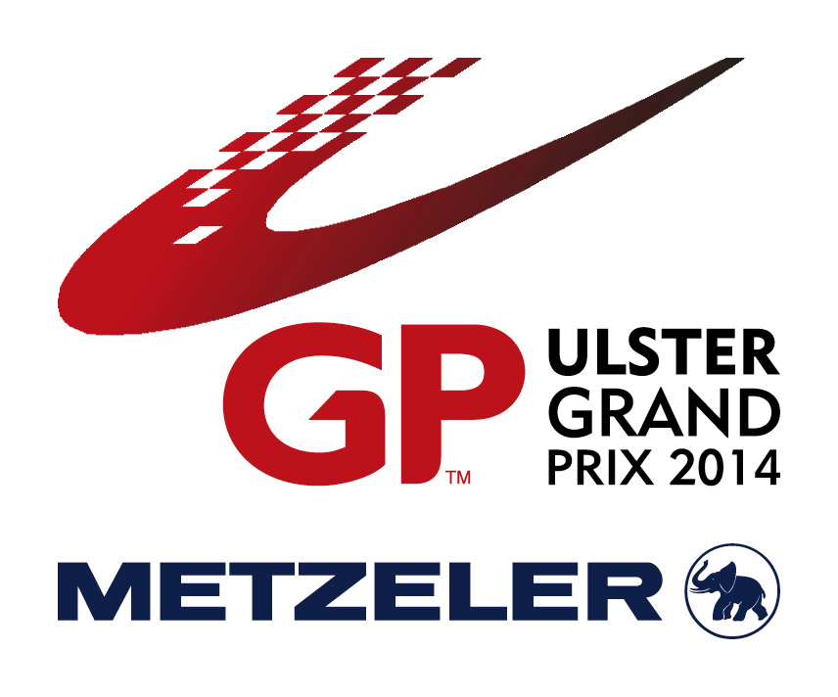
2014 Media Accreditation Application Form

Please note that media accreditation will only be issued to representatives of recognised news gathering outlets. All the information requested must be provided in full, and the application must be appropriately signed.

Journalists who have not been accredited with the MCUI and ALL photographers must apply using this form.

Please note: The number of media grid passes available is limited. The Dundrod and District Motorcycle Club’s decision on the allocation of these passes is final.

NB: Media accreditation will not be granted to anyone under 18 years of age.

Applications must be supported by the following:

- Three examples of work published within the last 12 months, relevant to the event and in a recognised publication or high profile website.
- A letter from your publishing editor – this must be on headed paper and should include a commitment to publish a report and/or photos of the event

Photographers only:
Do you have public liability insurance? (Yes/No)

If yes, please forward a copy along with your application.

A. Your details
Name:
Address:
Post code:
Mobile number:
Email:
Journalist/photographer:

B. Publication details
Title of publication:
Website:
Editor’s name:
Address:
Post code:
Telephone number:
Email:
C. Indemnity – please read before signing
I declare that I am over 18 years of age and am not suffering from any mental or physical disability that would impair my judgement or prevent me from acting in a safe manner.

I agree to act, at all times, in accordance with the instructions from event officials and to remain within the designated safe areas around the circuit.

I acknowledge and accept the potential risk inherent in motorsports and will undertake my role with proper regard for my safety and that of others. I further declare that I have read the Rules and Regulations governing the sport and agree to abide by them.

I agree to keep indemnified the Dundrod and District Motorcycle Club and its respective officials from and against all actions, claims, costs, expenses and demands in respect of death of, injury to, loss or damage of the person or property of myself.

Photographers only - I am happy to provide a £10 deposit for a photographer’s bib, which will be refunded upon its return.

Finally, I understand that a media accreditation pass does not grant any rights for television/video/film/electronic gathering or any other form of moving picture coverage to be used in any commercial operations without prior written agreement from the Dundrod and District Motorcycle Club.

Signature of applicant: ______________________________________

Signature of editor: ______________________________________

Date submitted: ______________________________________

D. Completed applications
Please send completed media accreditation forms via post or email to
Andrew McClenaghan at Baxter Public Relations.
Email: andrew@baxterpr.co.uk
Address:
2nd Floor
10 Cromac Place
The Gasworks
Belfast
BT7 2JB
Telephone: 028 9032 5533

